**15.9.2020 AN 2 SESSION**

1. There is a set of 36 distinct points on a plane with the following characteristics:

* There is a subset A consisting of 14 collinear points.

* Any subset of three or more collinear points from the 36 are a subset of A.

How many distinct triangles with positive area can be formed with each of its vertices being one of the 36 points? (Two triangles are said to be distinct if at least one of the vertices is different)

Collinear Points 🡪 Points Lying on a same line

Co -linear points

Coplanar points or Coplanar Lines 🡪 Points or Lines lying on the same plane.

D

A B C

2 points are always collinear

3 points need not be collinear.

A, B, C are collinear.

A,B,C & D as non collinear points

C,D is collinear

BCD, ABCD non collinear points

36 distinct points

14 are collinear

1 2 14 points (Collinear Points)

1 22 points (Non Collinear points)

22C3 🡪Select 3 points out of 22 non collinear points

22C2 * 14C1 🡪Selecting 2 points from non collinear category & 1 point from collinear category

22C1 * 14C2 🡪 Selecting 1 point from non collinear category & 2 points from collinear category

QUESTION WILL BE,

In how many ways can u draw a triangle with the vertices being one of the 36 points.

1 from collinear & 2 from Non collinear category or 2 from collinear & 1 from Non collinear category or 3 from non collinear category

14C1 * 22C2 + 14C2 * 22C1  + 22C3 = 6776.

2. There is a set of 27 distinct points on a plane with the following characteristics:

* There is a subset A consisting of 15 collinear points.

* Any subset of three or more collinear points from the 27 are a subset of A.

How many distinct triangles with positive area can be formed with each of its vertices being one of the 27 points? (Two triangles are said to be distinct if at least one of the vertices is different)

15 points (Collinear Points)

12 points (Non Collinear points)

12C1 * 15C2 + 15C1 * 12C2 + 12C3 = 2470

15C1 * 12C2 + 15C2 * 12C1 + 12C3 = 15 * 66 +105 * 12 + 2 * 11 * 10 = 990 + 1260 +220 = 2470

3. Two circles with centres P and Q cut each other at two distinct points A and B. The circles

have the same radii and neither P nor Q falls within the intersection of the circles. What is

the range that includes all possible values of the angle AQP in degrees?

a) Between 0 and 90 b) Between 0 and 30 c) Between 0 and 60 d) Between 0 and 75 e) Between 0 and 45

Q

P r r

CIRCLES ARE TOUCHING A CIRCLES ARE OVERLAPPING

P r A r Q P r Q

B B

Angle AQP = 0 degrees TRI PAQ is an equilateral triangle

Angle AQP = 60 degrees

4. In the medieval times, the sheikdom of Al kurazi had a proud tradition of inventing their own measurements units. The unit for distance was du, and the unit of time was pu. Unfortunately exactly what these measurement units are in modern terminology has been lost. The sheikh of Al Kurazi had built a huge mansion in the desert (near an oasis) with a circular wall around it, and the wall had four gates pointing north, south, east and west. He had built three observation towers, one 144 du to the north of the north gate, one 135 du to the east of the south gate, and one 7 1/2 du to the east of the east gate. They had been aligned to be all in a straight line passing thru the oasis. What was the diameter of the wall that surrounded the city (in Du)?

a) 178

b) 183 A(Watch Tower 1 )

c) 180 144 du

d) 181

r

D r 15 / 2 du(Watch tower 2 )

E

r

B 135 du C (Watch tower 3)

Triangle ADE & ABC 🡪are similar triangles.

Base of Small Triangle / Base of Large triangle = Height Of small Triangle / Height of large triangle

DE / BC = AD / AB = AE / AC

(r + 7.5) / 135 = (144 + r) / (144 + 2r)

r = 90 du

Diameter will be 2 * 90 = 180 du.

5. A solid wooden toy is in the shape of a right circular cone mounted on a hemisphere, such that the circular base of the cone rests on the flat circular area of the hemisphere. The radius of the hemisphere is equal to the radius of the circular base of the cone. If the radius of the hemisphere is 4.2 cm and the total height of the toy is 10.2 cm, find the volume of the wooden toy (approximately to the nearest integer)

a) 266cm3

b) 104 cm3

c) 162 cm3 6 mRadius of cone = Radius of H Sphere = 4.2cm

d) 427 cm3

r

10.2 cm

r (4.2 cm)

volume of Cone +Volume of Hemisphere

1/3 Pi * r2 * h + 2 / 3 *Pi * r3

1/3 * 22 / 7 * (4.2)2 * 6 + 2/3 * 22/7 * (4.2)3 =266.12cm3

O

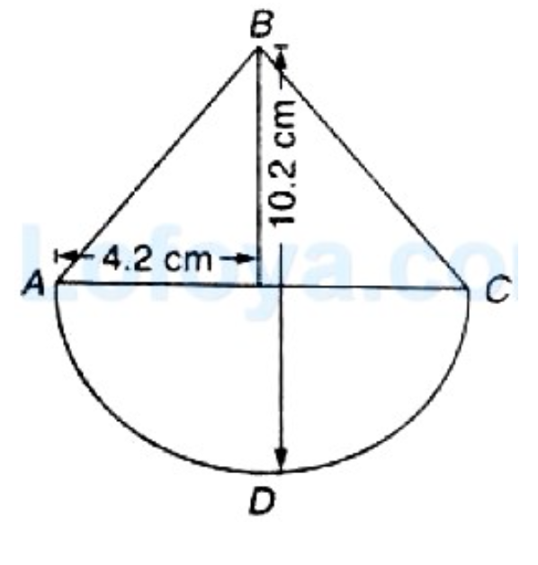

OD = OA = OC = 4.2 cm = Radius of Hemisphere or Radius of the circular base of the cone.

OB = BD – OD = 10.2 cm – 4.2 cm = 6cm 🡪HEIGHT OF THE RIGHT CIRCULAR CONE

Volume of Toy = Volume of the cone +Volume of the Hemisphere.

1 / 3 pi r2 h + 2 pi r3

= 1 / 3 pi (4.2)2 6 + 2 pi (4.2)3 pi = 22 / 7

6. In how many ways can you form parallelograms by a set of 4 parallel lines intersecting another set of 7 parallel lines?

a) 125 b) 126 c) 127 d) 128

A B C D E F G

1

2

3

4

2 lines out of 4 parallel line and 2 lines out of 7 parallel lines

4C2 * 7C2 = 6 * 21 = 126 Parallellogram

1 parallelogram we need 2 lines from 1st parallel lines category and 2 lines from 2nd parallel lines category

4C2 * 7C2 = 6 * 21 = 126

7.

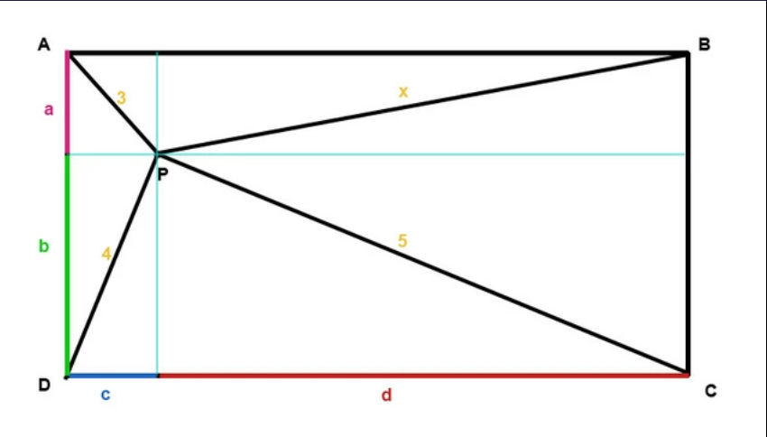

ABCD is a Rectangular room and a person P is standing inside the room and his distances from the three corners are given as

3,4,5. What is the distance from the 4 th corner.

PA = 3 ; PB = x ; PC = 5; PD = 4

PA2 + PC2 = PB2 + PD2

9 + 25 = x2 + 16

18 = x2

x =3 root 2.

8. There is a conical tent in which 10 persons can stand. Each person needs 6m2 to stand and 60m3 air to breath. What is the height of tent?

h

r

Area of the base of the Cone is the area of a circle with radius of the cone.

For 10 ppl we need 60m2

Pi r2 = 60 m2

Foe 10 ppl we need 600m3 of air

1 / 3 Pi r2 h = 600 m3

(1 / 3) * 60 * h = 600

h = 600 / 20 = 30 m